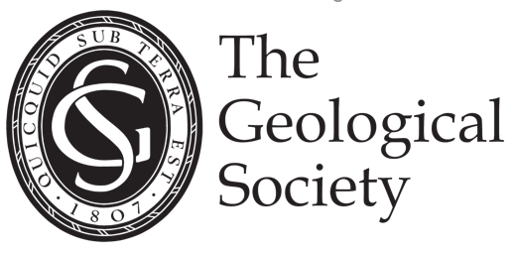

**Background information on the President-designate election and the role of President**

Dear Fellow,

Thank you for considering standing for election as President-designate.

As President Designate and then as President, you would be one of the 23 Council Members and would provide leadership to Council. Council Members are the trustees of the Society, and their prime responsibility is to oversee the affairs of the Society and to act prudently in the management of its financial resources. They take the big strategic decisions and make sure we are carrying out the Society’s purposes for the public benefit, acting in the charity’s best interests, managing our resources responsibly, being accountable, and acting in accordance with the rules.

A general call for Council Member nominations was in the autumn 2024 *Geoscientist* with a closing date for all nominations on 13 January 2025.

The President-designate election ideally would have two candidates take part in the preliminary ballot but inevitably this means one of the two will not be successful.

The President-designate and the incoming Council are formally elected at the AGM in June 2025.  During the session 2025/26 the President-designate attends meetings of Council (five a year) and is a member of the Finance & Planning Committee (which meets five times a year and is chaired by the Treasurer) and the time commitment in the first year is less.

This is a voluntary role be for one year as President-designate 2025/26 and two years as President from June 2026 to June 2028. The time commitment as President is 25-30 days per annum.

The President’s core activities are:

* Agreeing the Council agenda items and chairing Council
* General engagement in some high-level Society business
* Chairing the Elections, Officers and Awards Committees
* Giving one public lecture during their term either at Burlington House and/or virtually.

Candidates should have distinguished themselves in their chosen sector of geosciences and will have achieved recognition in industry, academe or government.

The role will be to:

* Be an ambassador for the Geological Society, as both a learned society and a professional body
* Champion the application of geoscience for public benefit
* Represent the Geological Society to government and stakeholders
* Bring together the range of interests and stakeholders to work together to further the Society’s objectives
* Provide strategic leadership

The individual will have:

* Highly developed interpersonal skills – especially in active listening and collaborative decision making
* The ability to engage effectively with a diverse range of stakeholders
* Chairing and meeting management skills
* Good judgement
* Ability to see the big picture, prioritizing amd focusing on big important things rather than minor points and pet projects
* A commitment to the role of professional organisations and designations
* High level achievement in their field of science
* A good reputation for their collaborative leadership skills
* Networking skills with an ability to foster consensus, collaboration and collective action
* The credibility and ability to work with and influence government and other decision-formers at the highest level

**SUPPORTING STATEMENT**

Your nomination requires a supporting statement. This should be no longer than 250 words and should contain:

* What you will bring to the role of President and your vision for the Society
* Whether you have previously served on Council and membership of any of its committees
* Current job (and if relevant previous jobs, for example, if you have moved from academe to industry)
* Number of years Fellowship of the Society
* Membership of which specialist groups including any roles held
* Qualifications and whether a Chartered Geologist, Chartered Scientist or other professional designation